Python for everybody – python data structures

[9.1 - Dictionaries](https://www.coursera.org/lecture/python-data/9-1-dictionaries-rQKjf)9m

9.2 - Counting with Dictionaries11m

9.3 - Dictionaries and Files13m

[10 - Tuples](https://www.coursera.org/lecture/python-data/10-tuples-0ou0N)17m

Worked Exercise: Tuples and Sorting

Graduation

I have finished the remaining weeks left in the python data structures course.

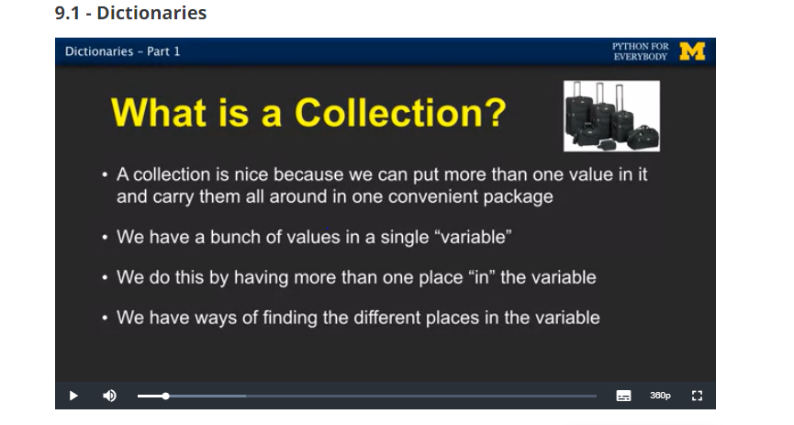

Dictionary- “bag” of values, each with its own label

No order

Dictionaries are like a list except they use keys instead of numbers to look up values

Dictionary literals have a key: value pairs

You can make an empty dictionary using curly braces 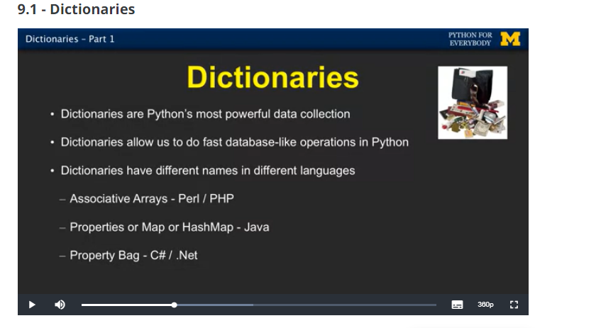

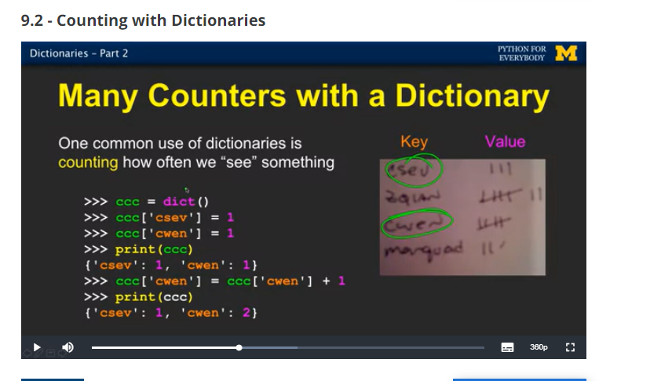

Error to reference key that’s isn’t in didct

We can use an ***in*** operator to see if a key is in the dictionary

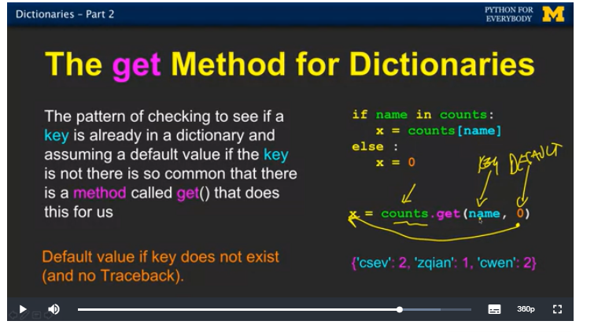

9.3

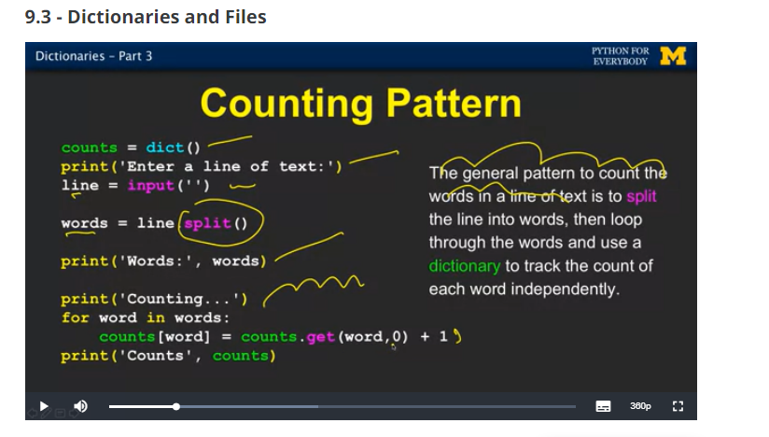

You can get lists of keys and values or items both from a dictionary

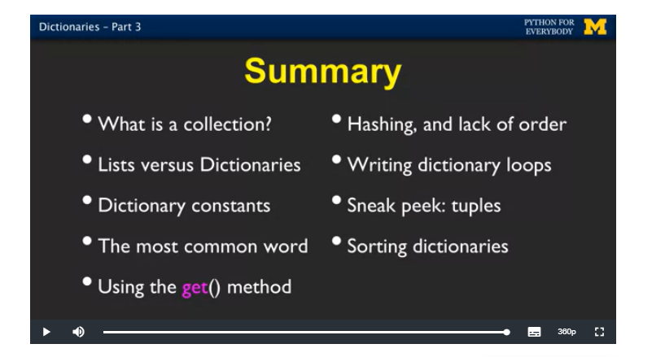

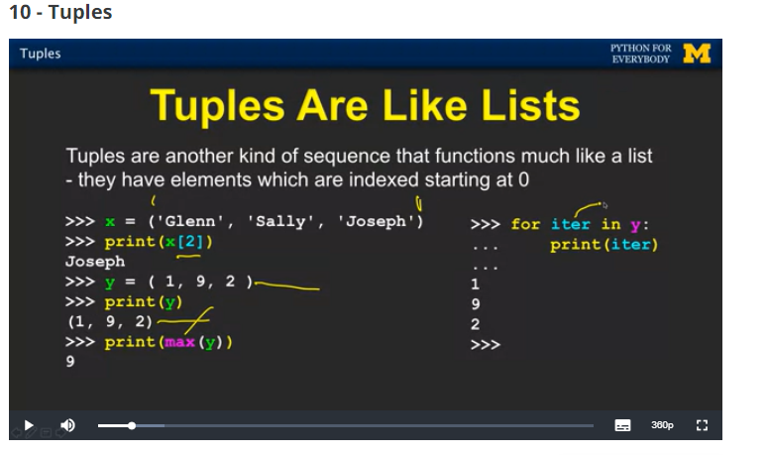

Indexed numbers

Not changeable (immutable)

Comparison operator works with tuples and other sequences. If the first term is equal python goes on to the next element on and on

We can sort list of tuples

